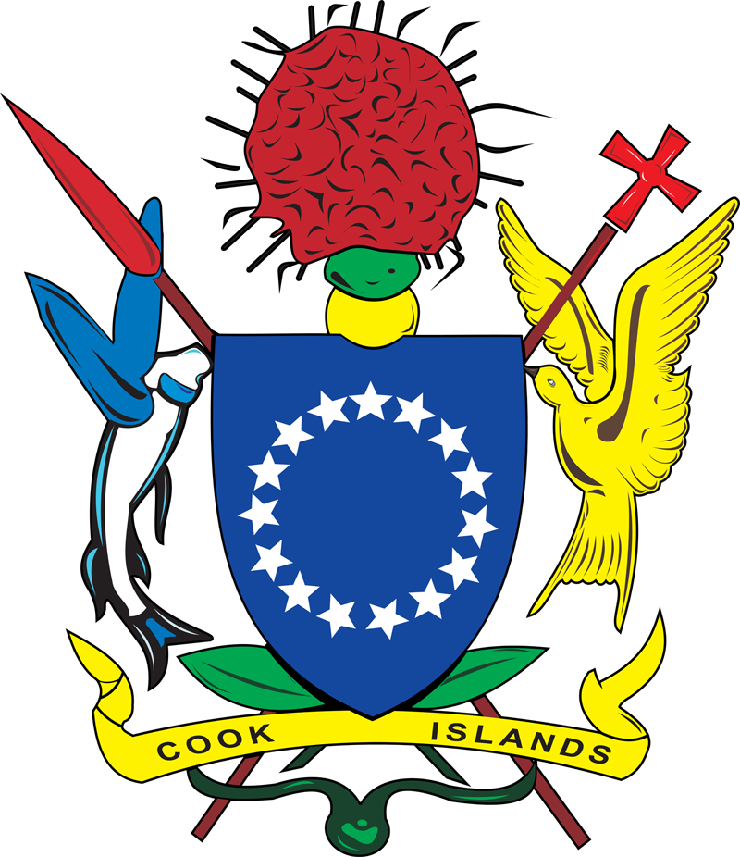 | COOK ISLANDS  APPLICATION FOR SAFE MANNING | Ship Registration  FORM 6 v1

Safe Manning Applications will be reviewed in accordance with IMO Assembly Resolution A.1047(27) Principles of Minimum Safe Manning

VESSEL PARTICULARS
NAME OF SHIP | CALL SIGN | IMO NUMBER | GROSS TONNAGE  (ITC 69) | TOTAL PROPULSION (kW) | PORT OF REGISTRY
OPERATING COMPANY
COMPANY NAME
COMPANY IMO NUMBER
GMDSS & UMS
Vessel Certified for GMDSS | Yes | No
Vessel Certified for UMS (Unattended Machinery Space Operations) | Yes | No
TRADING AREA
Unlimited / International |  | Other  Provide clear description and / map of trading area
Near Coastal
PROPOSED MANNING LEVELS
DECK |  |  | ENGINE
Grade/Capacity | STCW Reg.  (Or other) | No. Of Persons | Grade/Capacity | STCW Reg.  (Or other) | No. Of Persons
SPECIAL CONDITIONS
List special conditions that would apply to the vessels manning (if any)

Owner / Technical Manager Name | Signature of applicant
Date:

